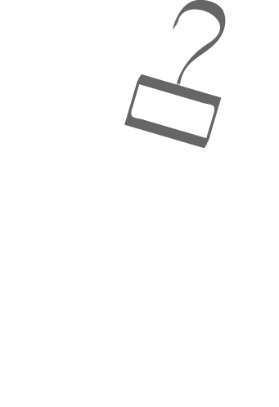

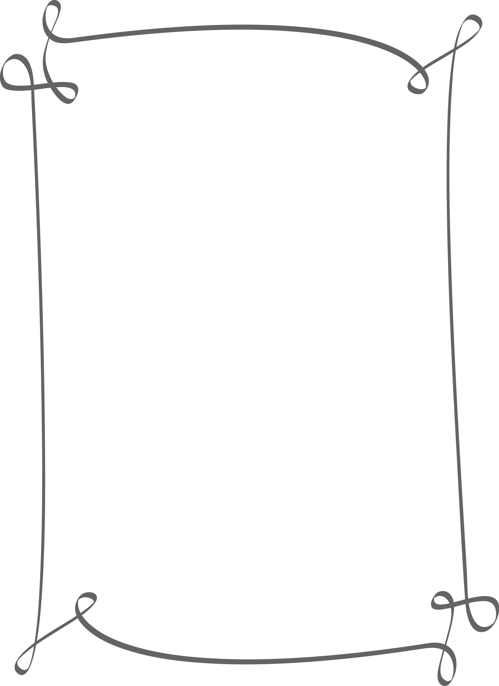

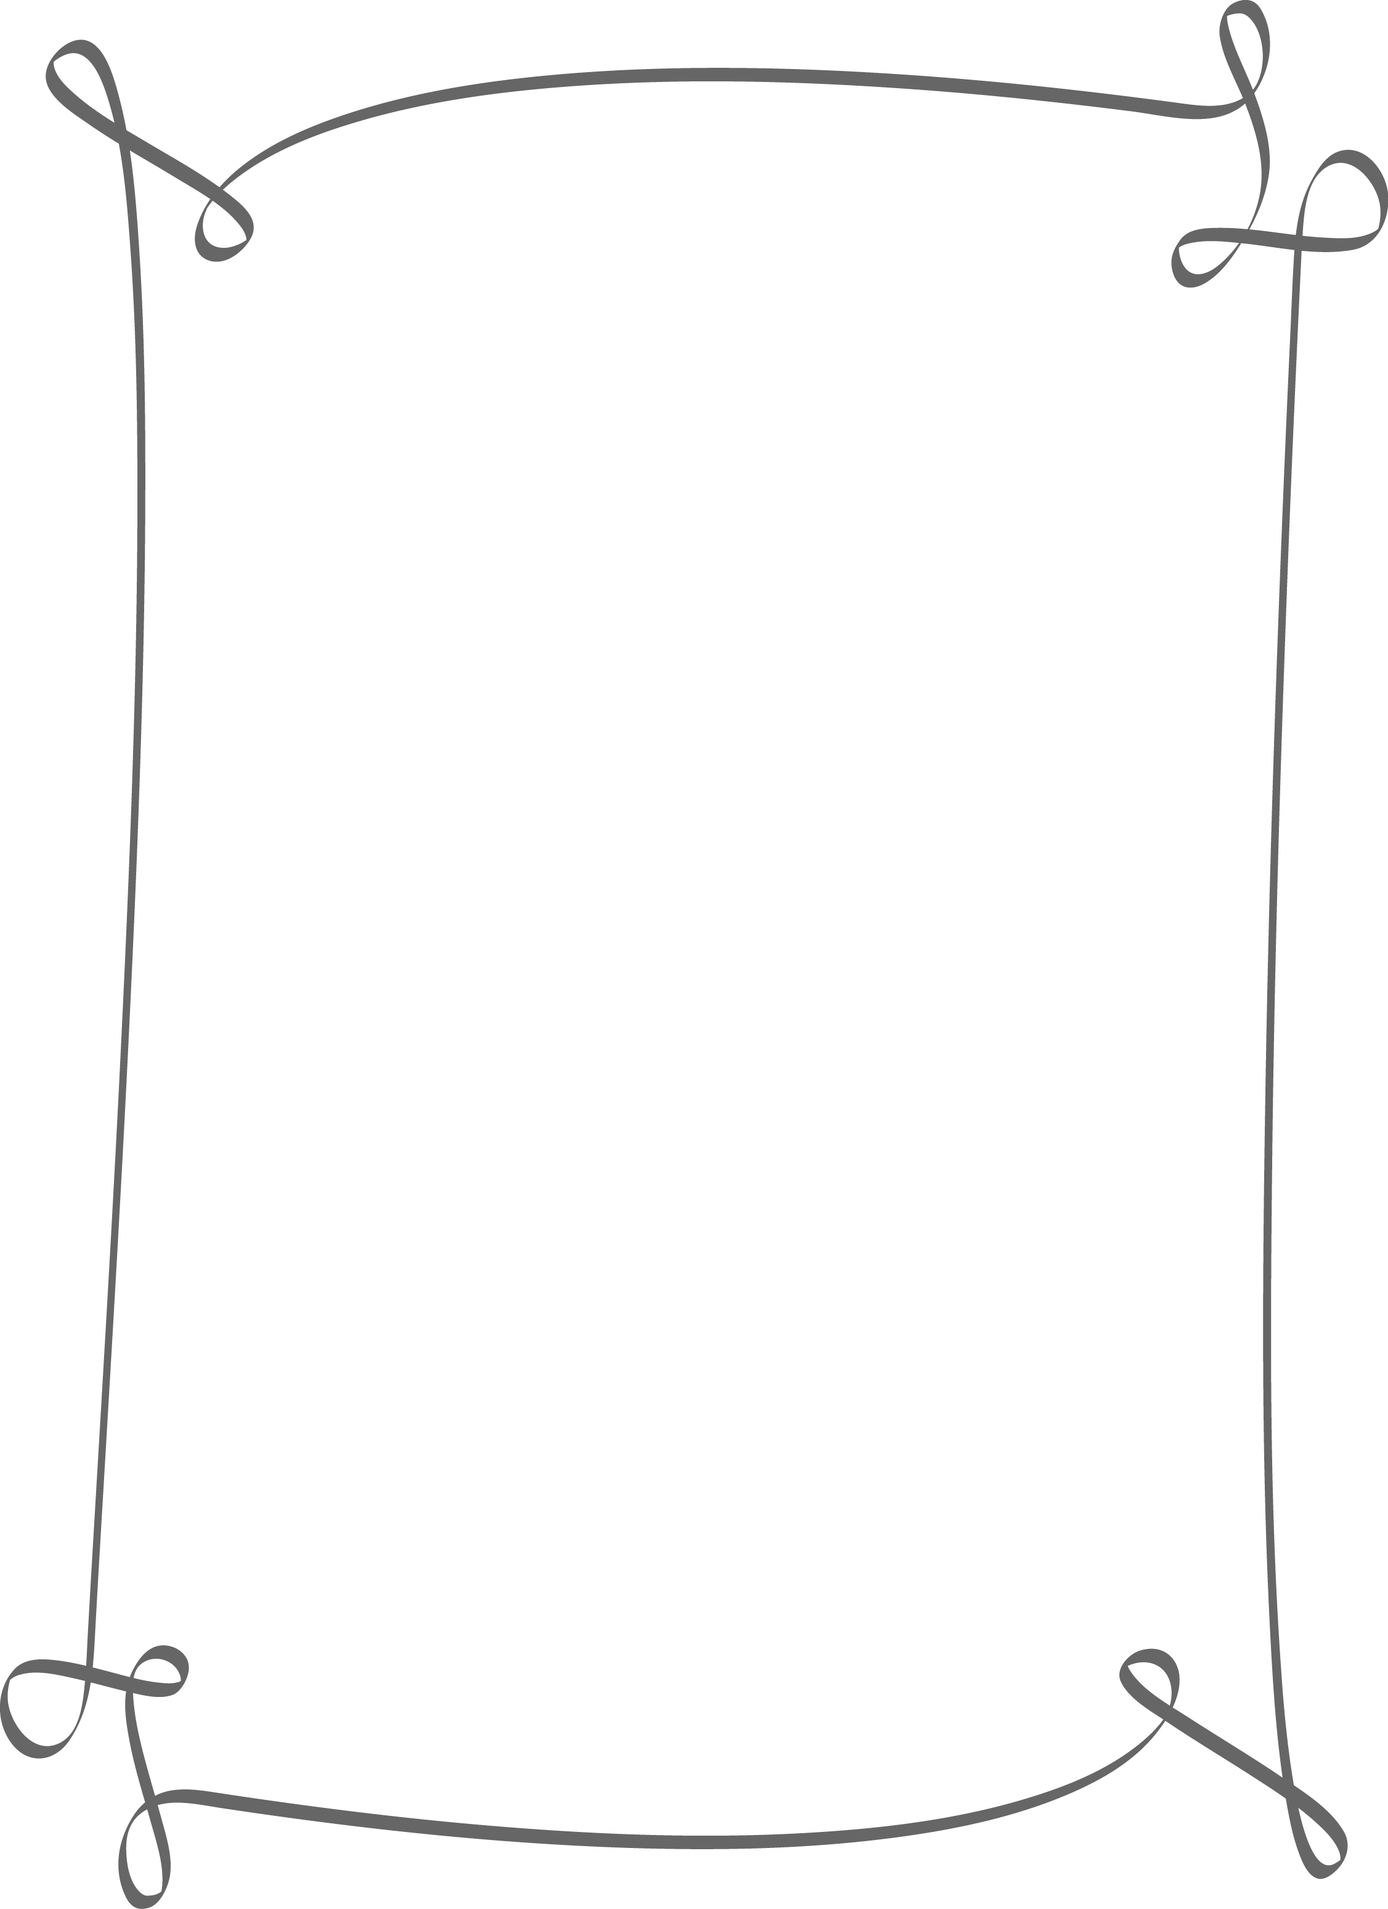

Blue Water Developmental Housing, Inc

Cordially Invites You to Our

# ANNUAL HOLIDAY PARTY

December 15th

5:00 p.m. to 7:00 p.m.

American Legion Hall

299 Huron, Blvd   
Marysville, MI 48040

Please R.S.V.P. by November 27th, 2017 to   
your designated Program Manager at  
Name:_____________________________  
Phone #____________________________

